**Use Case Specification with Sequence Diagram**

Use case Specification with supporting system sequence diagram as follows:

***Use case Specification 1:*** Human gets kit and immune himself from zombie

**Actors:**

1. Human
2. Kit
3. Message
4. Zombie

**Preconditions:** Game has been started and Human is still alive.

**Basic Flow of events:**

1. Human sees the kit’s position.
2. Human moves towards kit avoiding any contact with Zombie.
3. Human intersects with the kit and get it.
4. Scoreboard is updated as “Kit: Available”
5. Human intersects the zombie and is still alive.
6. As Human used this kit, new kit will pop up at any place on the screen.

**Alternate flow:**

Human intersects with the Zombie before taking kit and gets killed.

**System Sequence diagram for kit:**

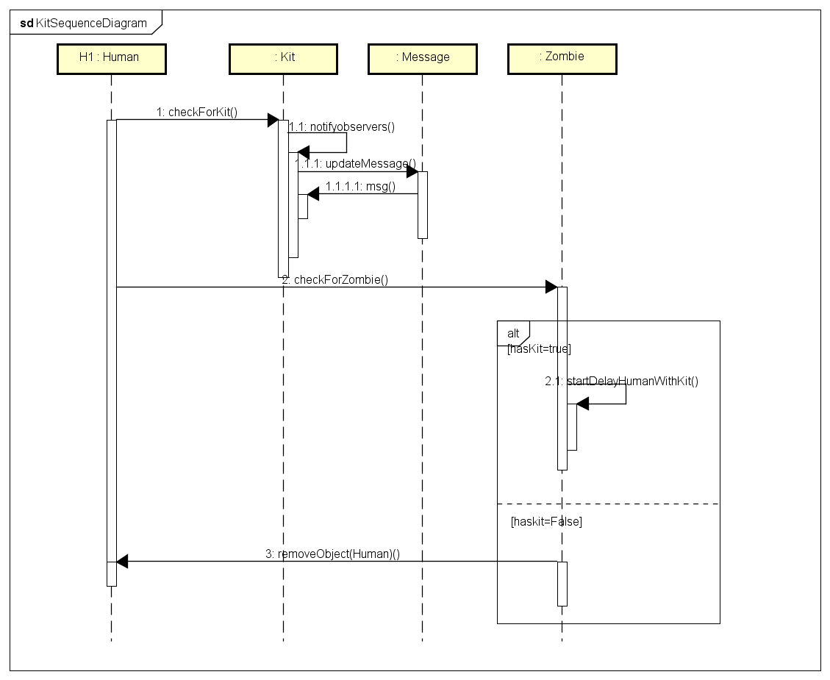

***Use case Specification 2:*** Human gets gun and kills the Zombie with bullet.

**Actors:**

1. Human
2. Gun
3. Bullet
4. Zombie

**Preconditions:** Game has been started and Human is still alive.

**Basic Flow of events:**

1. Human sees the gun’s position.
2. Human moves towards gun avoiding any contact with Zombie.
3. Human intersects with the gun and get it.
4. Scoreboard is updated as “Gun: Available”
5. Human shoots bullet at the Zombie and kills it.
6. Human has unlimited number of bullets after getting the gun, so he can kill any number of zombies with gun.

**Alternate flow:**

Human intersects with the Zombie before taking gun and gets killed.

**System Sequence diagram for gun:**

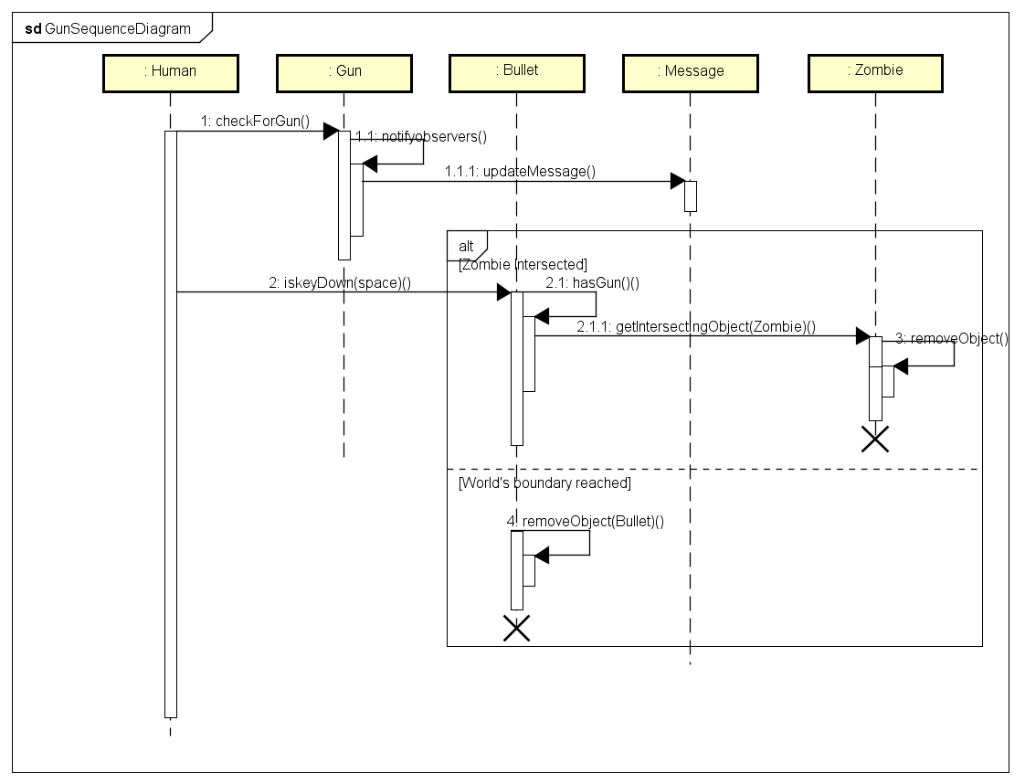

***Use case Specification 3:*** Human gets food and increment his score.

**Actors:**

1. Human
2. Food
3. Message

**Preconditions:** Game has been started and human is still alive.

**Basic Flow of events:**

1. Player see the food’s position.
2. Move the human towards food avoiding any contact with Zombie.
3. Human intersect with the food and get it.
4. Scoreboard is updated as “Food: 1”
5. After Human collects three food items, system displays three more food items at random places on the screen.

**Alternate flow:**

1. Human intersects with the Zombie and gets killed.
2. Human keeps playing the game without any food.

**System Sequence diagram for food:**

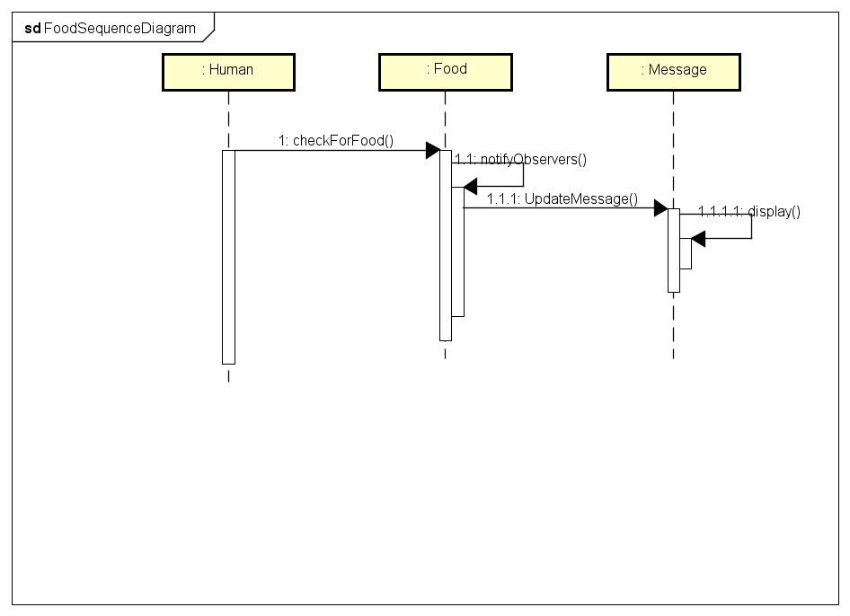

***Use case Specification 4:*** Human gets full sword and kills the zombie.

**Actors:**

1. Human
2. Sword
3. Message
4. Zombie

**Preconditions:** Game has been started and human is still alive.

**Basic Flow of events:**

1. Human see the positions of blade and handle.
2. Human moves towards blade or handle.
3. Human intersect with the blade or handle and get it.
4. Scoreboard is updated as “Sword parts: 1 out of 2”.
5. Human moves towards the other part of sword and get it.
6. Scoreboard is updated as “Sword: Available”
7. Human intersects with Zombie and kills it.
8. After killing one zombie by sword, another set of sword pops up on the screen.

**Alternate flow:**

1. Human intersects with the Zombie and gets killed.

**System Sequence Diagram for Zombie:**

